Agriculture in Sri Lanka is a chained business model, where each segment of the chain is independent and owned by the relevant entity. E.g. farmers own the land and produced agricultural products, mills are owned by separate entities who purchase products from farmers, the milled product is the sold to agriculture corporate agencies.

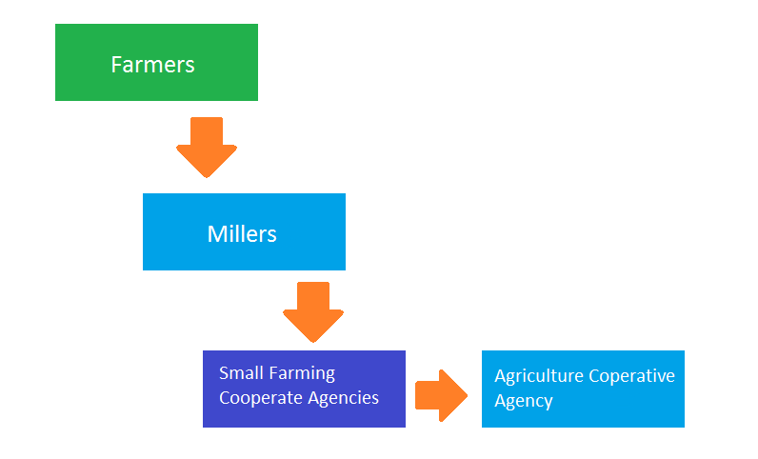

Figure : Workflow of the entities

Your task is to develop a stand-alone application with the relevant analysis and documentation inclusive to facilitate an auction application that will run in the district agricultural department, you must perform the necessary analysis to identify the operating environment, technical skill levels of the users. The system is most used by farmers who come to the agricultural department once in four months (typically after each harvesting period).

Currently the system operates in manual transaction, there are possibilities for market manipulation, farmer experience low satisfaction in profits (wealth distribution is not equal in the chain), heavy workload to sell the product, high cost, security issues, there are possibilities of misplacement of relevant documents such farmers documents

**Summary**

* Farmers sell to millers.. they sell to small farming cooperate agencies they sell to agriculture cooperative agency
* User class will have like UserID, First/ Last name, contact no, address (u can decide what classes to be need when it comes to an auction)
* Need to have a GUI (Which automatically generates when you do in Java Fx) no need beautiful graphics and all.
* My suggestion is to have like a BID class where the user places the bid, AUCTION class (Auction ID, Date, reserved price etc), a payment class, ITEM class (which includes wt type of thing they are selling). U can do like a bidder and auction thing (bidder u can have 3 types like farmer, miller, small farming..) or something like a buyer and a seller. U can do what ever u think it is easy. But it is upto you , you can come up with an idea
* Create logical things such as a close button like that. Don’t bother about colors

It would be easier if there are 2 separate functions like one is run by admin other is by sellers but it is upto you

Languages :-

* You need to do in **Java FX**.. the interface doesn’t need to be beautiful
* **Java**
* **SQL**

**This link includes an incomplete one (it has javafx part if you want) u can use it or do as u wish:-**

<https://drive.google.com/drive/folders/1EkriBdswyhJ7xPnQtJLYAqZgQj0ao-iI?usp=sharing>